**Appendix**

**Table 1.** Calculation of time intervals using different tolerance levels

|  |  |  |  |  |  |  |  |  |
| --- | --- | --- | --- | --- | --- | --- | --- | --- |
| id | game | day | Played? | tol.1 | tol.2 | tol.3 | tol.4 | tol.5 |
| id 1 | game 1 | 1 | Y | 1 | 1 | ~~1~~ | 1 | ~~1~~ |
| id 1 | game 1 | 2 | N | STOP | 1 | ~~1~~ | 1 | ~~1~~ |
| id 1 | game 1 | 3 | Y |  | 1 | ~~1~~ | 1 | ~~1~~ |
| id 1 | game 1 | 4 | N |  | STOP |  | 1 | ~~1~~ |
| id 1 | game 1 | 5 | N |  |  |  | 1 | ~~1~~ |
| id 1 | game 1 | 6 | N |  |  |  | 1 | ~~1~~ |
| id 1 | game 1 | 7 | Y |  |  |  | 1 | ~~1~~ |
| id 1 | game 1 | 8 | N |  |  |  | 1 | ~~1~~ |
| id 1 | game 1 | 9 | Y |  |  |  | 1 | ~~1~~ |
| id 1 | game 1 | 10 | Y |  |  |  | 1 | ~~1~~ |
| id 1 | game1 | 11 | N |  |  |  | STOP |  |



**Figure 1.** Distribution of id-specific variables



**Figure 2.** Distribution of game-specific variables

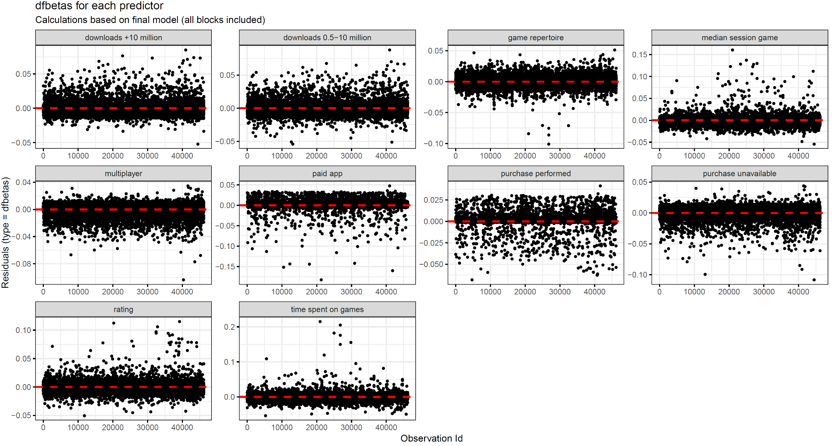**Figure 3.** Dfbetas for each predictor

**Table 2 .** Estimated parameters of Cox regression with time-dependent covariates | *adaptations for model robustness checks*

|  |  |  |  |  |
| --- | --- | --- | --- | --- |
| *Variable* | Cluster variance by game-level | *Games shared at most by 3 subjects* | *Less conservative estimate of in-game purchases* | *Apps not available on Google Play included* |
|  | *HR (95% CI)* | *HR (95% CI)* | *HR (95% CI)* | *HR (95% CI)* |
| purchases: **a** |  |  |  |  |
| purchase unavailable | 1.21 (1.15-1.29)*** | 1.10 (1.03-1.17)** | 1.19 (1.15-1.24)*** | 1.38 (1.34-1.43)*** |
| purchase performed | 0.72 (0.67-0.78)*** | 0.65 (0.52-0.82)*** | 0.72 (0.69-0.75)*** | 0.68 (0.64-0.73)*** |
| paid app | 1.00 (0.91-1.1) | 0.98 (0.88-1.09) | 1.00 (0.93-1.08) |  |
| multiplayer | 0.96 (0.9-1.01) | 0.97 (0.9-1.05) | 0.95 (0.92-0.97)*** |  |
| median session game | 1.04 (1.01-1.07)* | 0.95 (0.93-0.98)*** | 1.04 (1.02-1.05)*** | 1.03 (1.02-1.04)*** |
| rating |  |  |  |  |
| downloads: **b** | 0.89 (0.83-0.96)*** | 0.84 (0.79-0.89)*** | 0.89 (0.86-0.92)*** |  |
| 0.5-10 million | 0.94 (0.88-0.99)* | 0.97 (0.9-1.03) | 0.94 (0.9-0.98)** |  |
| + 10 million | 0.82 (0.77-0.87)*** | 0.96 (0.88-1.04) | 0.82 (0.79-0.86)*** |  |
| time spent on games | 0.79 (0.78-0.81)*** | 0.83 (0.81-0.86)*** | 0.80 (0.78-0.81)*** | 0.75 (0.74-0.77)*** |
| game repertoire | 1.70 (1.67-1.73)*** | 1.54 (1.45-1.63)*** | 1.69 (1.65-1.75)*** | 1.63 (1.58-1.68)*** |
| Wald-score (*p*) |  |  |  |  |
| a: reference category: ‘purchases available, but not performed’  b: reference category: ‘less than or equal to 0.5 million downloads” | | | | |
| * *p* < 0.05 ** *p* < 0.01 *** *p* < 0.001 | | | | |

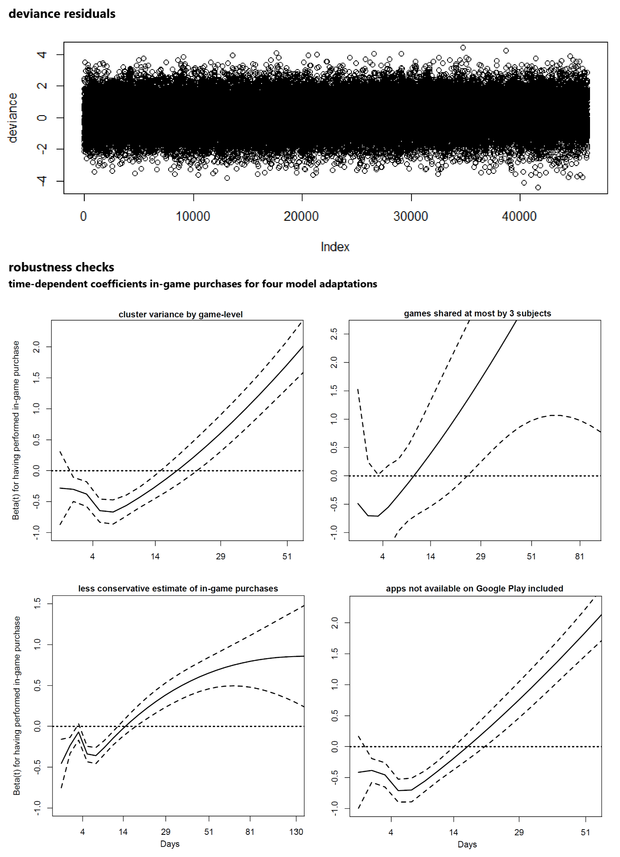

**Figure 4.** Martingale residuals and robustness checks